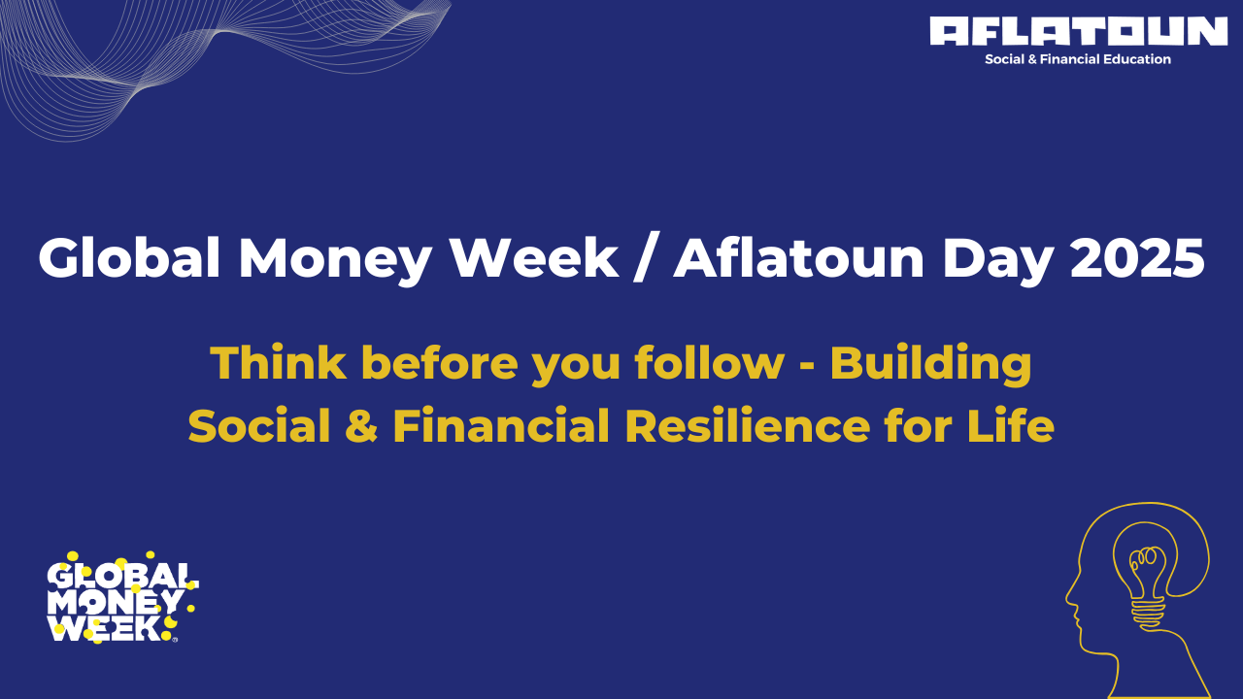

**Global Money Week 2025 and Aflatoun Day celebrations: "Think Before You Follow – Building Social and Financial Resilience for Life"**

**[Amsterdam/The Netherlands, 11th March 2025]** – Global Money Week (GMW) 2025 kicks off this March with an exciting new theme created by the Aflatoun network, **“Think Before You Follow – Building Social and Financial Resilience for Life.”**   
The initiative, which aims to raise global awareness about the importance of financial literacy among young people, will run from **March 17th to March 21st, 2025**.

GMW 2025, a spin-off from Aflatoun Day, coordinated by OECD, will reach millions of children and youth across 176 countries. The week-long campaign promotes financial and social resilience, teaching young people how to make informed decisions, manage their money, and adapt to the challenges they face in an ever-evolving financial landscape.

Through this year’s theme, the Aflatoun movement highlights the need for critical thinking in the face of financial pressures – from peer influence to misleading advice – encouraging young people to build strong money management skills and their social resilience.

“*We are determined to empower the next generations with the tools they need to succeed financially. By promoting critical thinking and financial resilience, Global Money Week and Aflatoun Day 2025 events will showcase that young people know how to navigate complex financial choices and will be able to secure a stable future,”* said **Roeland Monasch, CEO, Aflatoun International**. “*It is our obligation and role to continuously equip them with the knowledge and resources to make informed financial decisions, ensuring they are prepared for the challenges and opportunities that lie ahead in their financial journeys. In every corner of the world*.”

**Key elements of Aflatoun’s Global Money Week 2025 set of events:**

* **Educational content**: during the Global Money Week, Aflatoun partners will share key educational resources, highlight the importance of financial literacy, and showcase activities held during virtual events, including live online meetings and webinars, videos, and more.
* **Youth-led interactive activities**: through interactive Zoom calls and online engagements, young people will have the opportunity to exchange their best experiences with Social and Financial Education and learn from financial experts, ask questions, and deepen their understanding of learning about managing money with Aflatoun and its active learning model - in all corners of the world.
* **Regional engagement**: Aflatoun network partners are hosting events, creating content, and sharing educational resources to highlight their ongoing initiatives and engagement.

**How everyone can get involved in GMW 2025 celebrations?**

* **Social media** – share your experiences and activities, connect with us and comment using the hashtags **#GMW2025 #GlobalMoneyWeek2025 #AflatounDay #LearnShareEmpower #JoinTheMovement**. Follow the campaign on Aflatoun’s social media channels for daily updates, including videos, educational content, and partner highlights.   
  [Facebook](https://www.facebook.com/aflatoun/) [LinkedIn](https://www.linkedin.com/company/aflatoun/?viewAsMember=true) [Instagram](https://www.instagram.com/aflatoun_international/)
* **Join the Movement** - join the global effort to empower young people through financial education. Visit <https://gmw.aflatoun.org> to find more information about how you can get involved and see other Aflatoun partners in action! Visit our GMW landing page to access:
* An overview of Global Money Week and this year’s theme
* Event schedules and educational resources
* Media gallery with photos, videos, and highlights from celebrations
* Official press release and templates

As Global Money Week 2025 unfolds, we invite you to support this vital campaign. Together, we can help equip the next generation with the skills to make sound financial decisions, today and in the future!

**About Global Money Week:**Global Money Week (GMW) is a spin-off from Aflatoun Day coordinated by **OECD-OCDE**. The campaign aims to inspire and educate young people around the world about the importance of financial literacy and resilience. Since its inception in 2012, GMW has reached over **60 million children and young people** in **176 countries** globally.  
Visit: <https://gmw.aflatoun.org>

**About Aflatoun:**  
Aflatoun International is a global organisation committed to empowering young people through social and financial education. With a focus on social and emotional learning, entrepreneurship, and financial literacy, Aflatoun equips children and youth with the skills and knowledge needed to become active global citizens. **Since its inception in 2005, Aflatoun has reached over 100 million children in more than 110 countries**, transforming lives and communities worldwide.   
Visit: [https://aflatoun.org](https://aflatoun.org/)